<http://localhost:8765/> - Eureka

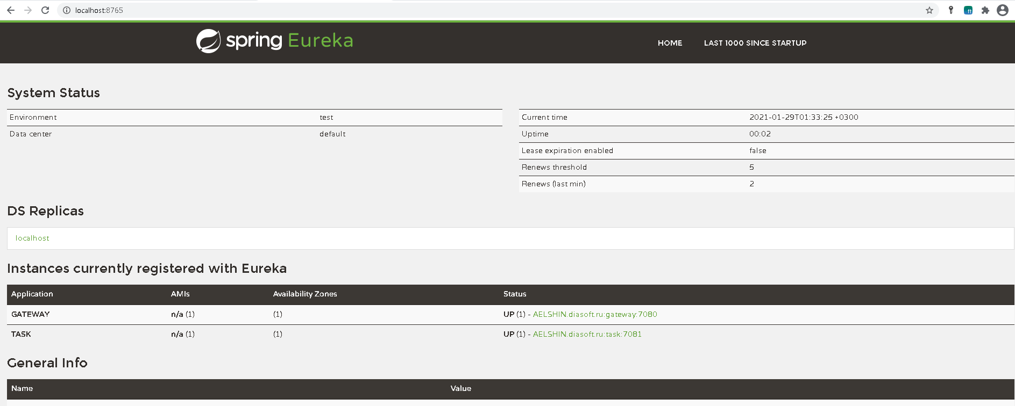

<http://localhost:7081/demo/swagger-ui/index.html> - Swagger post и get для demo

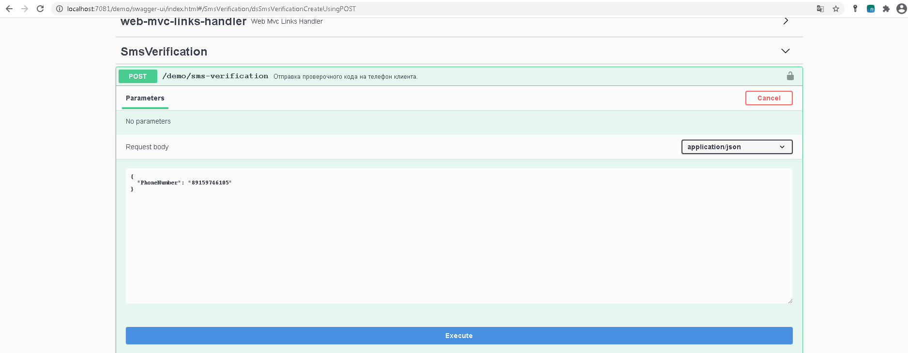

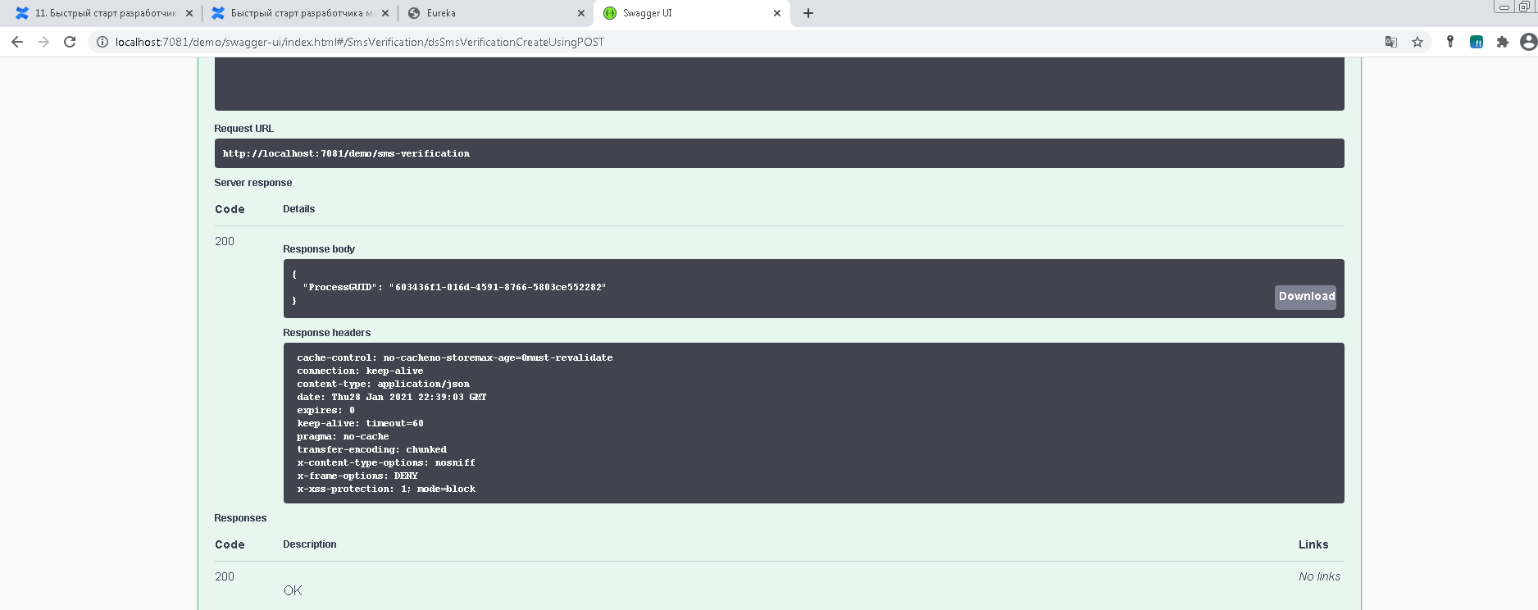

Проверка в БД

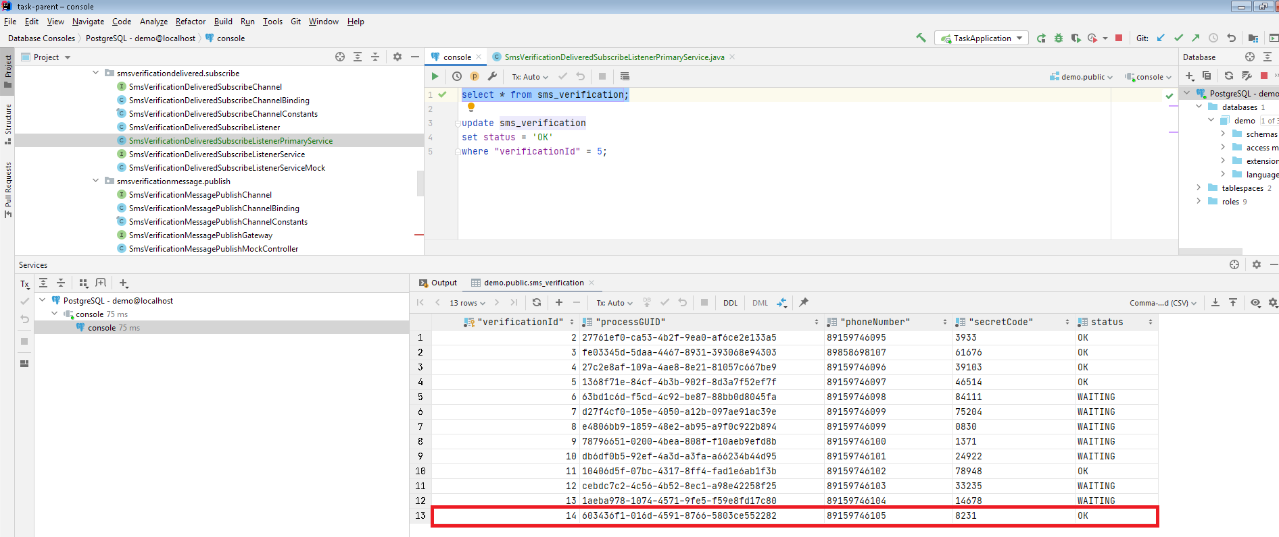

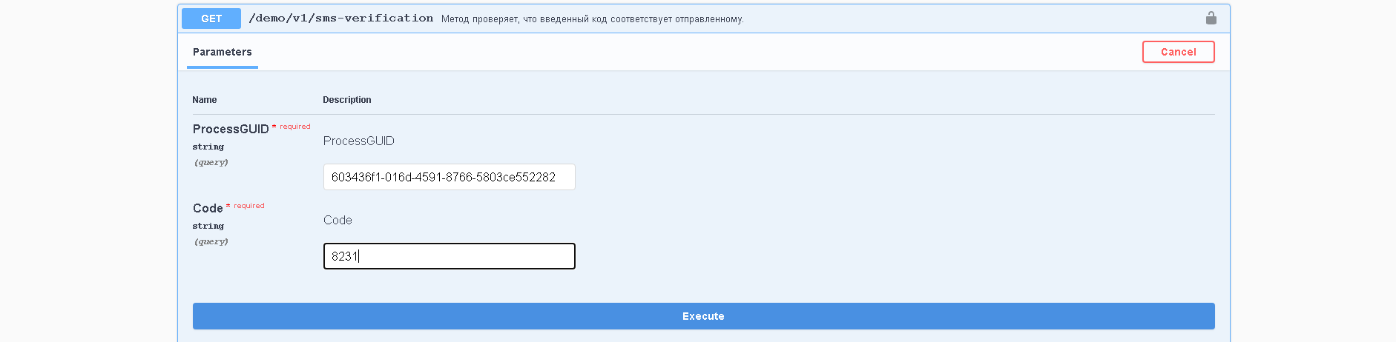

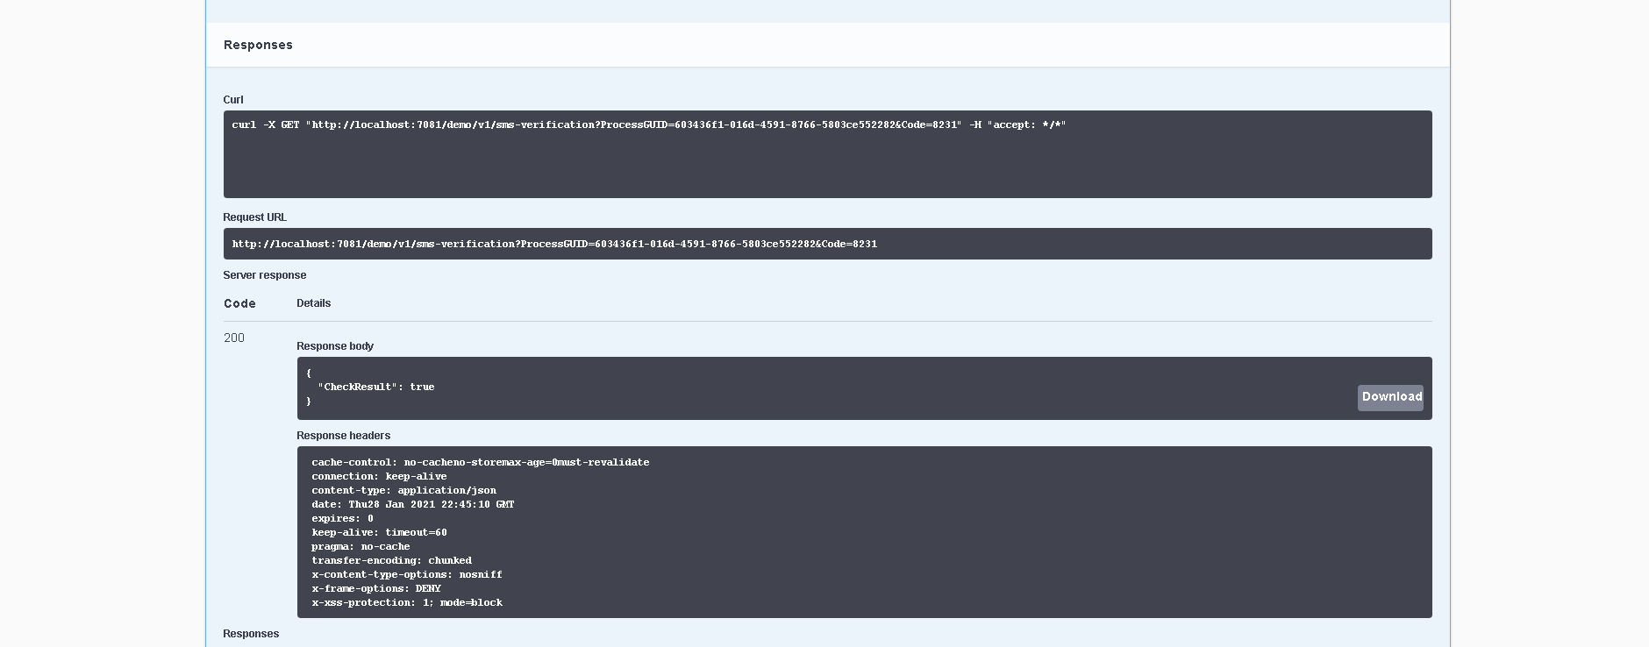

<http://localhost:7080/> - gateway

fetch(

'http://localhost:7080/sms-verification',

{

method: 'POST',

headers: { 'Content-Type': 'application/json' },

body: JSON.stringify({ PhoneNumber: '89159746106' })

}

).then(result => console.log(result))

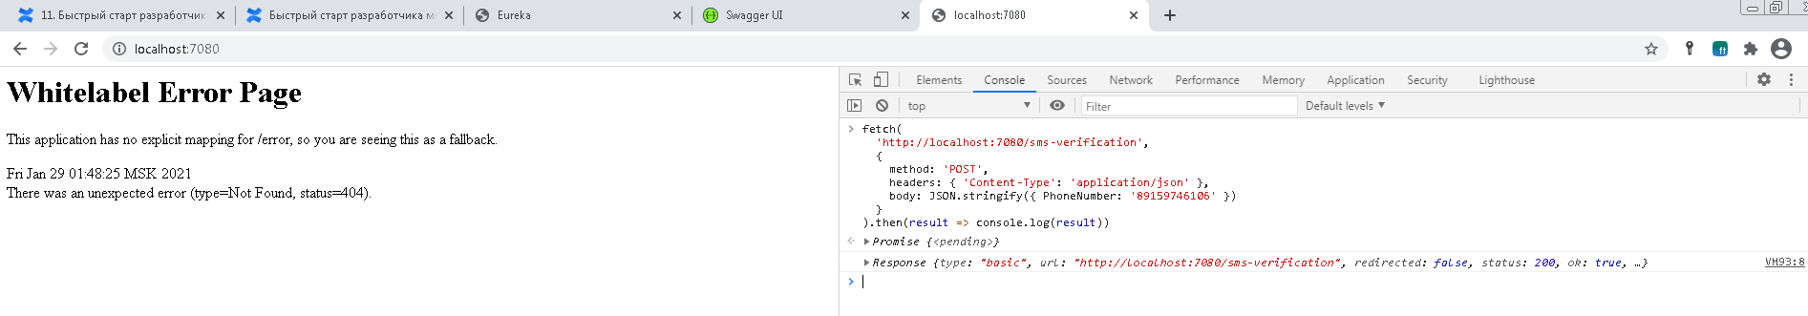

Проверка в БД

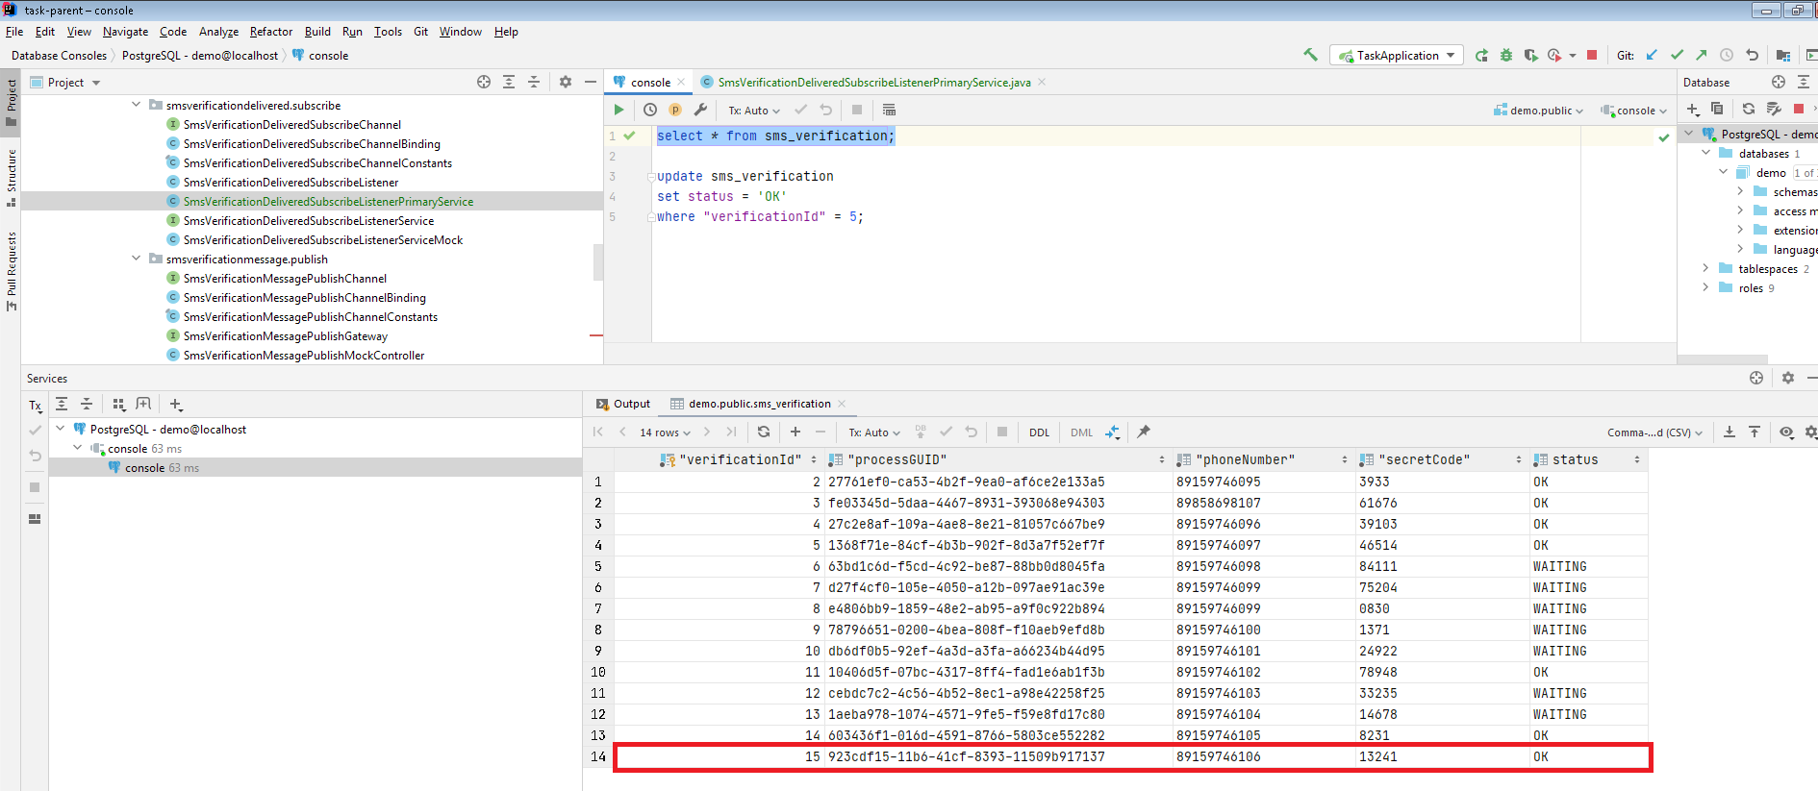

fetch('http://localhost:7080/v1/sms-verification?Code=13241&ProcessGUID=923cdf15-11b6-41cf-8393-11509b917137').then(response => response.json().then(console.log))

